- Sodium diatrizoate (SD) is a nonvolatile, water soluble X-ray contrast agent used for imaging of the gastrointestinal tract. A 0.378 m solution is prepared by dissolving 38.4 g of SD in 160. mL of water at 31.2 ̊C. The density of water at this temperature is 0.995 g/mL. What is the molar mass of SD (in g/mol)?

- 634.9 b) 638.1 c) 241.2 d) 631.7 e)NOTA

- Almost all drugs that are accumulated in the body do so by passive diffusion across the cell membranes. Therefore lipid solubility is a key factor in passive movement of drugs. As a result of this, drug companies must take this into account when manufacturing their drugs in order to ensure that the drugs reaches the correct compartment of the body and is able to have its desired effect. Knowing that aspirin is an acidic drug with a pK of 3.4. What percentage will be uncharged at the pH of the blood (7.4)?

- 100% b)4% c) 1% d) .01% e) NOTA

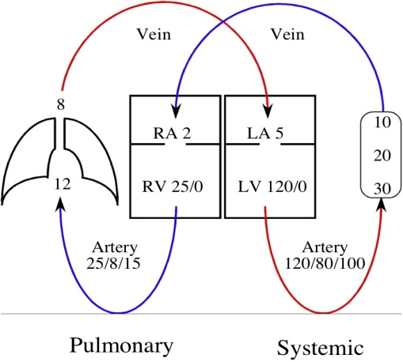
- One of the most important factors that determines the amount of blood flow to a particular organ is peripheral vascular resistance. Peripheral vascular resistance can be defined as $\frac{△P}{Cardiac Output}$ . Using the picture to the right about how many times greater is the systemic peripheral vascular resistance greater than the pulmonary vascular resistance? Normal cardiac output is 5 L/min.

- 4 x
- 12 x
- 5 x
- 33 x
- None of the above

- In a given population, only the "A" and "B" alleles are present in the ABO system; there are no individuals with type "O" blood or with O alleles in this particular population. If 200 people have type A blood, 75 have type AB blood, and 25 have type B blood, what are the allelic frequencies of this population?

- p = .79, q = .21 b) p = .52, q = .48 c) p = .92, q = .08 d) p = .73, q = .27 e) NOTA

- A standard solution is prepared for the analysis of fluoxymesterone (C₂₀H₂₉FO₃), an anabolic steroid. The molecular weight of fluoxymesterone is 336 g/mol. A stock solution is first prepared by dissolving 25.0 mg of fluoxymesterone in enough water to give a total volume of 500.0 mL. A 100.0-µL aliquot (portion) of this solution is diluted to a final volume of 100.0 mL. What is the concentration of the final solution in terms of molarity?

- 1.49 x 10⁻⁴ M b) 1.49 x 10⁻⁷ M c) 1.49 x 10⁻⁸ M d) 1.49 x 10⁻¹⁰ M e) NOTA

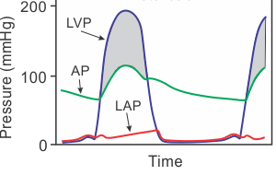
- In the heart, when a valve opens the two compartments connected to that valve should become equal in pressure. In certain circumstances, heart valves either become regurgitant (leaky) or stenotic (unable to open). Looking at the hemodynamic curve to the right, what is the most likely diagnosis? (LVP = Left Ventricular Pressure; AP = Aortic Pressure; LAP = Left Atrial Pressure)

- Mitral regurgitation
- Aortic regurgitation
- Aortic stenosis
- Mitral stenosis
- Pulmonic stenosis

- Blood alcohol (C₂H₅OH; mw = 46 g/mol) level can be determined by titrating a sample of blood plasma with an acidic dichromate solution. If 35.46 mL of 0.05961 M Cr₂O₇²⁻ solution is required to titrate 28.00 g of blood plasma, determine the mass percent of alcohol in the blood. The balanced redox equation is
16 H⁺ (aq) + 2 Cr₂O₇²⁻ (aq) + C₂H₅OH (aq) 4 Cr³⁺ (aq) + 2 CO₂ (g) + 11 H₂O (l)

- 4.86 % b) 19.45 % c) 0.17 % d) 0.69 % e) NOTA

- A patient comes to you with a history of asthma. You decide to prescribe terbutaline, a drug that opens up air passages in the lung. In order for the drug to be effective you must have a concentration of 2 µg/L in the body. So, you must account for the volume of distribution being 1.79 L/kg (volume of distribution is a theoretical volume in which the total amount of drug would need to be uniformly distributed to produce the desired blood concentration) and the oral bioavailability of this drug being 0.14 (bioavailability is a measurement of the extent to which a drug reaches the systemic circulation). What would be the appropriate loading dose for orally administered terbutaline for an 80 kg patient (in mg)?

- 0.0256 b) 2 c) 0.002 d) 0.511 e) NOTA

- Glucose-6-phosphate dehydrogenase deficiency (G6PD) is an X-linked condition common among Mediterranean and African peoples. Glucose-6-phosphate dehydrogenase deficiency is a condition in which red blood cells break down when the body is exposed to certain drugs or the stress of an infection. If 6.7% of Turkish-Cypriot men were found to have G6PD deficiency, what percentage of women are carriers for the abnormal gene?

- 0.9% b) 17.4% c) 6.25% d) 13.4% e) NOTA

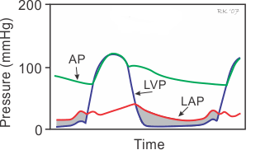
- One of the most important things that all doctors must be able to do is to be able to detect abnormal heart sounds when listening to a patient’s heart. You are in the clinic and you think that you hear a slight murmur (a murmur is an abnormal heart sound produced as a result of turbulent flow over an abnormal valve). You decide to send your patient to get a hemodynamic workup. Based on the curve to the right, which graph would best represent the heart sound you would have heard? (S1 = Atrio-ventricular valves closing; S2 = Aortic / Pulmonic Valves closing; LVP = Left Ventricular Pressure; AP = Aortic Pressure; LAP = Left Atrial Pressure)
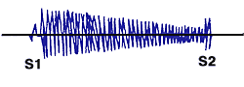

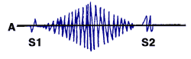

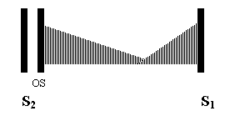

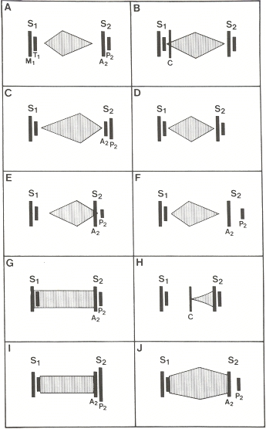

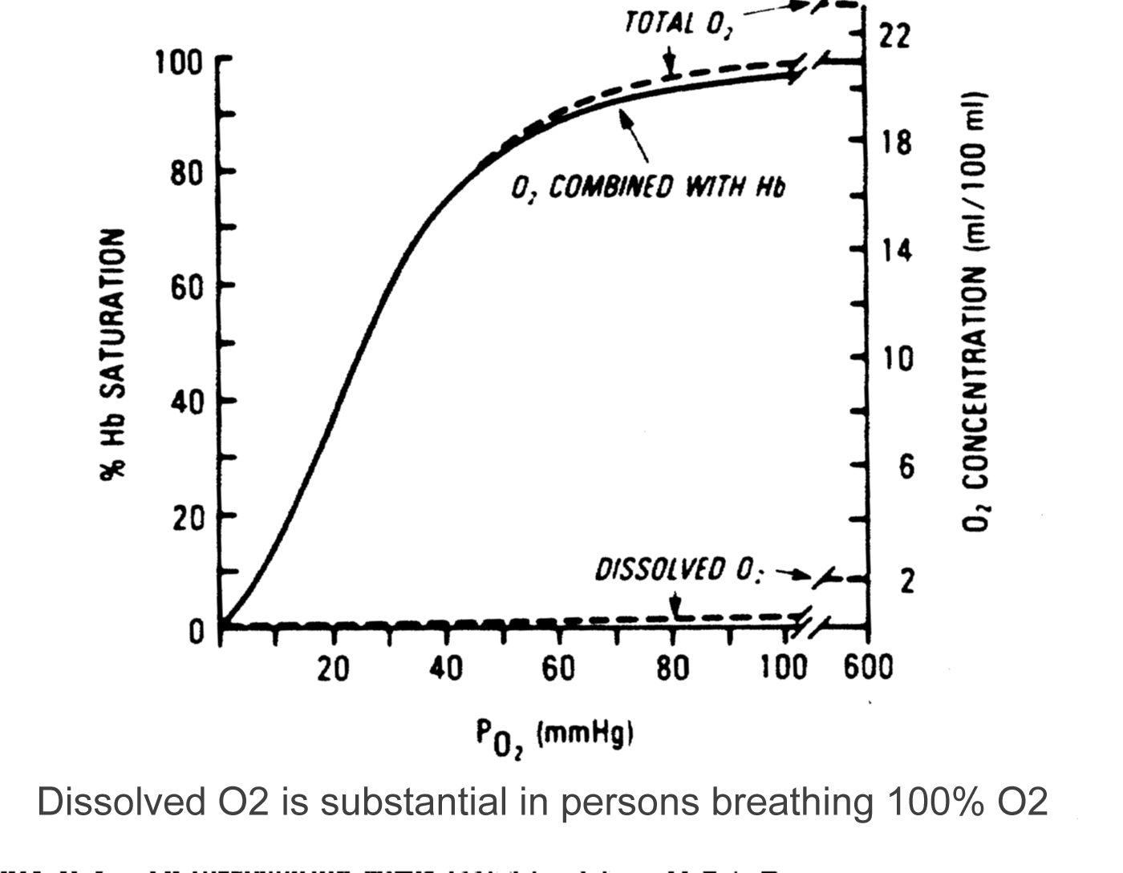
- One of the most important functions of our blood is to carry oxygen to all of the organs in the body. In the average human there is 15 g of Hb/ dL. Using the curve to the right, what would be the total O₂ content if a person is breathing 100% O₂ at 673 mmHg? (A gram of Hb can carry about 1.34 mL of O₂; dissolved O₂ in blood is 0.003 mL/dL/mmHg)

- 22.1 mL/dL b) b) 20.1 mL/dL
c ) 13.2 mL/dL d) 11.2 mL/dL e) NOTA

- A pregnant female at 8 weeks post last menstrual period visits her OB for prenatal care. This is her first pregnancy. She is affected with sickle cell anemia, an autosomal recessive disorder characterized by hemolytic anemia and intermittent episodes of vascular occlusion causing pain and swelling of the hands and feet, as well as chronic organ dysfunction. Her partner’s hemoglobin is normal, ruling out both disease and carrier status. The offspring of this couple are expected to be:

- 25% affected; 50% carriers; 25% unaffected, not carriers
- 50% affected; 50% carriers c) 50% unaffected, not carriers; 50% carriers
d ) 100% carriers e) NOTA

- The human eye is a complex sensing device for visible light. The optic nerve needs a minimum of 2.0 x 10⁻¹⁷ J of energy to trigger a series of impulses that eventually reach the brain. How many photons of red light (700 nm) are needed to stimulate an impulse? (Planck’s Constant = 6.626 x 10⁻³⁴ Js; Speed of light = 3 x 10⁸ m/s)

- 15 b) 70,430 c) 1.3 x 10³¹ d) 71 e) NOTA

- During times of high strenuous exercise, the body regulates blood flow and diverts blood and nutrients to where the body needs them. During these periods of high physical activity the body can increase the amount of blood flow to skeletal muscles 10x more than at rest. In order to assist the body in getting blood to the skeletal muscles, the heart contracts more often and with greater force. Given the information in the following table, what is the end diastolic volume (in mL) during strenuous exercise (the amount of fluid in the heart after the ventricle fills with blood)?

 | Rest | Strenuous Exercise
Cardiac Output | 6 L/min | 18 L / min
Heart Rate | 70 beats per minute | 160 beats per minute
Ejection Fraction | 60% | 80%
Arterial Pressure | 120/80 mmHg | 150/80 mmHg
Central Venous Pressure | 2 mmHg | 2 mmHg

- 11.1 b) 141 c) 113 d) 90.4 e) NOTA

- Ellie's daughter, Francis, has bilateral cleft lip with cleft palate. Family history reveals that Ellie’s mother, Dina, has two pits in her lower lip, as does his sister, Donna. A complete physical examination of Ellie, by a clinical geneticist, reveals a normal palate, normal teeth and no lower lip pits. Given the family history, Francis is diagnosed with Van der Woude Syndrome, a condition with 80% penetrance. What is Ellie’s chance of having another affected child?

Lip Pits

Donna
Lip Pits
Dina--Lip Pits

Charles
Elly—Normal Physical Exam, but has the affected gene.

Francis—Bilateral
Cleft Lip/Palate
?

- $1/2$
- $4/5$
- $2/5$
- $1/5$
e) NOTA

- Total blood cholesterol level, or technically “serum” or “plasma” cholesterol, is the concentration of cholesterol in the serum or plasma portion of the blood. Desirable levels are <200 mg/dL, borderline high is 200-239 mg/dL, and high risk is >240 mg/dL. Consider a hypothetical male weighing 186 lbs with serum cholesterol of 216 mg/dL. The total amount of cholesterol in this person’s blood would be equivalent to the total amount of cholesterol in how many dozens of eggs? Serum or plasma comprises 55% of blood by volume. (There are 4.7 L of blood per 160 lbs; average cholesterol per egg is 215 mg).

- 4.6 b) 85.6 c) 0.3 d) 24.7 e) NOTA

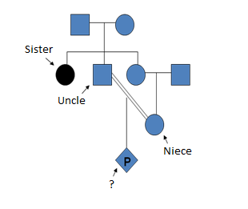
- One of the most concerning findings for a clinical geneticist is to discover a high level of inbreeding within a family. Inbreeding within a family leads to less gene transfer and an increased chance of recessive alleles to come together in order to cause a genetic defect. A clinical geneticist begins to counsel two patients, an uncle and niece who got married and are currently pregnant. The uncle has a sister with a recessive disorder. What is the chance that their baby will have the same disorder?

- $1/{18}$ b) $1/{32}$ c) $2/9$ d) $1/4$ e) NOTA

- Hemoglobin is the protein that transports O₂ through the blood from the lungs to the rest of the body. In doing so, each molecule of hemoglobin combines with four molecules of O₂. If 1.00 g of hemoglobin combines with 1.53 mL of O₂ at 37 ̊C and 0.978 atm, what is the molar mass of hemoglobin (in g/mol)? (The gas constant is 0.08206 $\frac{L x atm}{K x mol}$).

- 6.8 x 10⁴ b) 1.7 x 10⁴ c) 4.3 x 10³ d) 8.1 x 10³ e) NOTA

- The ability to taste the chemical phenylthiocarbamide is an autosomal dominant phenotype, and the inability to taste it is recessive. If a taster woman with a nontaster father marries a taster man who in a previous marriage had a nontaster daughter, what is the probability that their first child will be a taster boy?

- $3/4$ b) $1/4$ c) $3/8$ d) $1/2$ e) NOTA

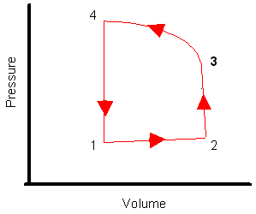
- On the graph showing left ventricular volume and pressure, at which point does the aortic valve close?

- 1
- 2
- 3
- 4
- NOTA

- Edema can be caused by many things in the human body such as: increased hydrostatic pressure, reduced oncotic pressure, increased tissue oncotic pressure, increased blood vessel permeability, and obstruction in fluid clearance. In a capillary, the pressure is 30 mmHg and the oncotic pressure is 25 mmHg. In the surrounding interstitial space, the pressure is -2 mmHg and the oncotic pressure is 2 mmHg. What is the direction of fluid movement and the net driving force?

- 9 mmHg; filtration into the capillary
- 9 mmHg; filtration out of the capillary
- 1 mmHg; filtration into the capillary
- 1 mmHg; filtration out of the capillary
- NOTA

- John and Martha are contemplating having children, but John’s brother has galactosemia (an autosomal recessive disease in which the body is unable to metabolize the sugar galactose) and Martha’s great grandmother also had galactosemia. Martha has a sister who has three children, none of whom have galactosemia. What is the probability that John and Martha’s first child will have galactosemia?

- $1/6$ b) $1/{16}$ c) $1/32$ d) $1/8$ e) NOTA

- Cardiac output of the right side of the heart is what percentage of the cardiac output of the left side of the heart?

- 15% b) 39% c) 76% d) 100% e) NOTA

- Duchenne muscular dystrophy is sex-linked and usually affects only males. Victims of the disease become progressively weaker, starting in early life. If your father’s brother had the disease, what is the probability that you have received the allele?

- 0% b) 25% c) 50% d) 75% e) NOTA

- Cardiac output, the volume of blood ejected per minute, can be measured by looking at the oxygen content found in the venous and arterial blood. The following measurements were obtained in a male patient:
Central Venous Pressure | 10 mmHg
Heart Rate | 70 beats/min
Pulmonary Vein [O₂] | 0.24 mL O₂ / mL
Pulmonary Artery [O₂] | 0.16 mL O₂ / mL
Whole Body O₂ Consumption | 500 mL / min

What is the patient’s cardiac output (in L/min)?
- 6.25 b) .16 c) 437.5 d) .09 e) NOTA

- A couple who are about to get married learn from studying their family histories that, in both their families, their unaffected grandparents had siblings with cystic fibrosis (a rare autosomal recessive disease that causes a sticky mucus to build up in the lungs and the digestive tract). If they have four children, what is the chance that the children will have the precise Mendelian (standard) ratio of 3:1 for normal:cystic fibrosis?

- ${27}/{256}$ b)$3/{256}$ c) $3/{1024}$ d) $1/9$ e) NOTA

- In the body, aspirin breaks down by a first order process. 30 minutes after consuming a standard dose of this compound, it reaches a maximum concentration of 2 mg/100mL of blood. If t_{1/2} = 90 minutes, what is the concentration (in mg/100 mL) 2.5 hrs after it reaches its maximum concentration? (ln 2 = .693)

- e^{0.674} b) e^{1.85} c) e^{-0.462} d) e^{0.712} e) NOTA

- One of the most important ways that the body maintains blood pressure is by constricting blood vessels and increasing the vascular resistance. Determine the vascular resistance of a resting skeletal muscles from the following data:
Mean Arterial Pressure | 100 mmHg
Mean Venous Pressure | 0 mmHg
Blood flow to the muscle | 5 mL/min

- .05 $\frac{mmHg x min}{mL}$
- 500 $\frac{mmHg x min}{mL}$
- 20 $\frac{mmHg x min}{mL}$
- .002 $\frac{mmHg x min}{mL}$
- NOTA

- Hydroxyapatite, Ca₅(PO₄)₃(OH), is the main mineral component of dental enamel, dentin, and bone, and thus has many medical uses. Coating it on metallic implants (such as titanium alloys and stainless steels) helps the body accept the implant. In the form of powder and beads, it is used to fill bone voices, which encourages natural bone to grow into the void. Hydroxyapatite is prepared by adding aqueous phosphoric acid to a dilute slurry of calcium hydroxide. What mass (in g) of hydroxyapatite could form from 100. g of 85% phosphoric acid and 100. g of calcium hydroxide?
3 H₃PO₄ + 5 Ca(OH)₂ Ca₅(PO₄)₃(OH) + 9 H₂O

MW of H₃PO₄ = 98 g/mol; MW of Ca(OH)₂ = 74.09 g/mol; MW of Ca₅(PO₄)₃OH = 502.31 g/mol

- 145.2 b) 170.9 c) 1307.1 d) 3390.7 e) NOTA

- Vitamin B12, cyanocobalamin, is essential for human nutrition. It is concentrated in animal tissue, but not in higher plants. Although nutritional requirements are quite low, people who abstain completely from animal products (and don’t take a vitamin supplement) may develop a deficiency anemia. Cyanocobalamin contains 4.34% cobalt by mass. Calculate the molar mass of cyanocobalamin (in g/mol), assuming that there is one atom of cobalt in every molecule of cyanocobalamin. (MW of Co = 58.93).

- 13. 58 b) 255.76 c) 639.39 d) 33.95 e) NOTA

