- A regular hexagon has a perimeter of 12 cm. What is its area in square inches?
A) 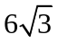 B) 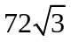 C) 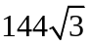 D) 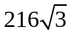 E) NOTA
- One angle of a regular polygon measures 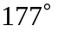. How many sides does it have?
A) 89 B) 120 C) 177 D) 183 E) NOTA
- 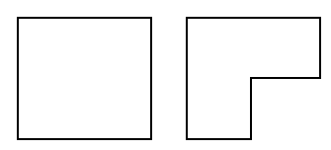One-fourth of the area of a square with each side measuring 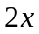 cm is sectioned off and removed. (“Before And After” pictures of the procedure appear to the right.) The area removed is itself square-shaped. What is the perimeter of the resultant figure in centimeters?
A) 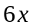 B) 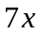 C) 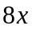 D) 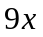 E) NOTA
- A rhombus has diagonals measuring 6 cm and 10 cm. What is its area in square centimeters?
A) 30 B) 32 C) 60 D) 64 E) NOTA
- Octagon ABCDEFGH is similar to octagon JKLMNOPQ. If 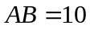, 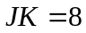, and 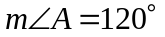, what is 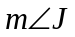 in degrees?
A) 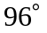 B) 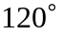 C) 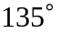 D) 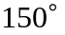 E) NOTA
- Find the sum of the measures of one interior and one exterior angle of a regular 40-gon.
A) 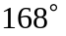 B) 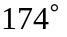 C) 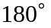 D) 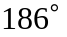 E) NOTA
- A right triangle with legs measuring 12 cm and 16 cm is inscribed in a circle. What is the circumference of the circle in centimeters?
A) 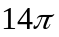 B) 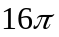 C) 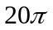 D) 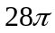 E) NOTA
- A square has a diagonal measuring 8 cm. When its area is expressed as 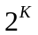 square centimeters, what is K?
A) 4 B) 5 C) 6 D) 7 E) NOTA
- 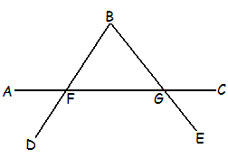In the diagram to the right, 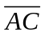 intersects 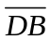 at F and intersects 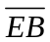 at G. If 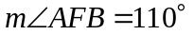 and 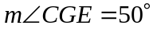, what is 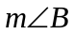 in degrees?
A) 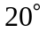 B) 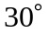
C) 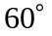 D) 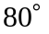 E) NOTA
- One angle of a parallelogram measures 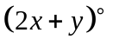. Another angle of the same quadrilateral (but not the opposite angle) measures 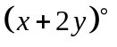. What is 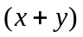?
A) 30 B) 60 C) 90 D) 120 E) NOTA
- A right triangle with integral side lengths has one leg measuring 30 cm. Which of the following could not be the length of its hypotenuse in centimeters?
A) 34 B) 50 C) 65 D) 78 E) NOTA
- 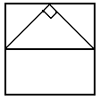An isosceles right triangle is inscribed in a square. Its hypotenuse is a midsegment of the square. What is the ratio of the triangle’s area to the square’s area?
A)  B) 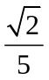 C) 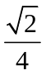 D)  E) NOTA
- A central angle measuring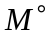 intercepts an arc in a circle of radius r cm. The length of the subtended arc is 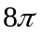 cm. The area of the sector formed by (and including) the angle is 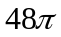 cm². Evaluate 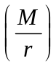.
A) 5 B) 10 C) 20 D) 40 E) NOTA
- A regular hexagon with a perimeter of 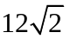 units lies in the Cartesian plane in such a way that its center is on the origin, two of the vertices lie on the x-axis, and the midpoints of two of its sides lie on the y-axis. If the portion of the hexagon that lies in Quadrant I is completely revolved around the x-axis, a solid whose volume is X cubic units results. If the same portion is completely revolved around the y-axis, a solid with a volume of Y cubic units results. Evaluate 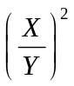.
A) 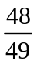 B) C) 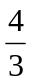 D) 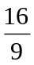 E) NOTA
- 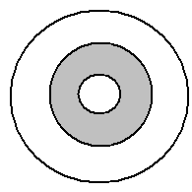Three distinct concentric circles (shown to the right) have radii in the ratio of 3:4:5. A point is selected at random from within the largest circle. What is the probability that the point is also inner the center annulus (in the shaded “middle ring”)?
A) B) C) 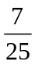 D) 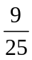 E) NOTA
- In the convex trapezoid JBLS, 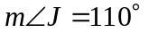. What is 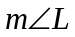?
A) 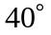 B) 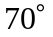 C) 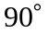 D) 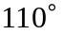 E) NOTA
- How many diagonals are in a convex nonagon?
A) 27 B) 45 C) 54 D) 79 E) NOTA
- Angle A of pentagon ABCDE measures one-fifth the sum of the other angles. Find 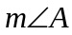.
A) 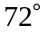 B) C) 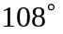 D) E) NOTA
- 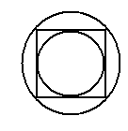 A circle is inscribed inside a square. The square is inscribed inside another circle. If the area of the small circle is cm², what is the area of the large circle, in square centimeters?
A) 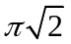 B) 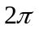
C) 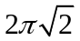 D) 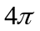 E) NOTA
- The apothem of a regular pentagon is 2.2 feet long. To the nearest tenth, one side of the pentagon measures 3.2 feet. In square feet to the nearest integer, what is the area of the pentagon?
A) 15 B) 18 C) 20 D) 23 E) NOTA
- On the Cartesian plane, a triangle exists whose vertices are the intersections of the lines 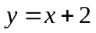, 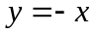, and 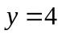. Which of the following phrases correctly describes the triangle?
A) Equilateral B) Isosceles acute
C) Isosceles obtuse D) Isosceles right E) NOTA
- 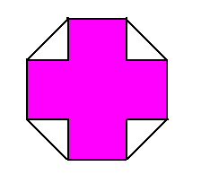 A concave dodecagon (the cross shown to the right) is inside of, and shares four nonconsecutive sides with, a regular octagon. Each reflex angle of the dodecagon measures 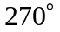, and every other interior angle of the dodecagon is a right angle. If the octagon has a perimeter of 16 cm, what is the area of the dodecagon in square centimeters?
A) 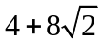 B) 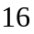 C) 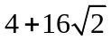 D) 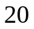 E) NOTA
- A mad professor shrinks a 409-gon. The procedure is very clean; the resultant polygon is similar to the original, but has only 50% of its area. What is the ratio of the perimeter of the shrunken 409-gon to that of the original?
A) B) C) D) 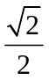 E) NOTA
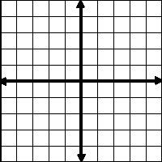
- A polygon in the Cartesian plane includes the following points on its perimeter: {(3, 0), (5, 4), (1, -1), (0, 3), (5, 2), (-4, 2), (4, 4)}. What is the least number of sides that the polygon could have?
A) 4 B) 5
C) 6 D) 7 E) NOTA
- A circle is inscribed in a triangle with sides measuring 4 cm, 6 cm, and 8 cm. What is the area of the circle in square centimeters?
A) 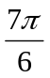 B) 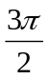 C) 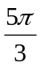 D) 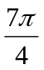 E) NOTA
- A circle with radius 18 cm is circumscribed about regular 18-gon ABCDEFGHIJKLMNOPQR. What is the length of 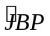 in centimeters?
A) 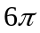 B) 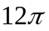 C) 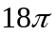 D) 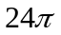 E) NOTA
- 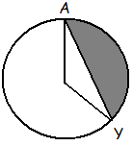In a circle with a 12” radius, minor arc 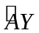 measures . The area of the segment bounded by and 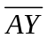 (shaded in the diagram) is 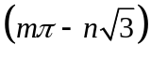 square inches, where m and n are integral. Find 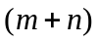.
A) 64 B) 72
C) 76 D) 84 E) NOTA
- 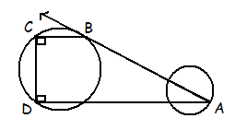 Point A lies on a circle, and point B lies on a larger circle, as shown in the diagram. The circles are external to each other.  is tangent to the large circle at B. Points C and D also lie on the large circle. Additionally, 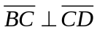 and 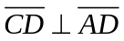. If 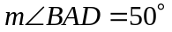, find the measure of .
A) B) C) 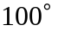 D) 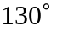 E) NOTA
- 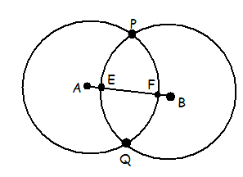Congruent circles with centers A and B intersect each other at P and Q as shown in the diagram. 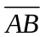 intersects the circle with center A at F and it intersects the circle with center B at E. Which of the following most specifically describes the type of quadrilateral that EPFQ must be?
A) kite B) parallelogram
C) rhombus D) trapezoid E) NOTA
- The area, in square centimeters, of a regular dodecagon with one side measuring x cm can be expressed as 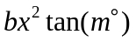, where b and m are rational. What is the value of 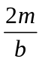 ?
A) 5 B) 10 C) 25 D) 50 E) NOTA

