If not explicitly stated, choice (e) is None of the above choices (NOTA). Also, unless explicitly stated, it is assumed that all matrix multiplications consist of matrices of appropriate dimensions so that the product exists. Also, assume all matrices are square when taking determinants.

- If and v, then calculate .

(a) 12 (b) 8 (c) –8 (d) – 12 (e) NOTA

- What is the inverse of

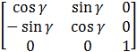

For = 30º

- 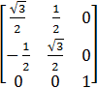 (b) 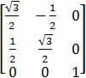 (c)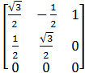 (d) 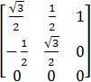

(e) NOTA

- Compute the multiplication 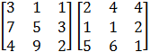

- 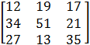 (b) 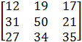 (c) 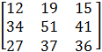 (d) 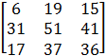

(e)NOTA

- Solve for (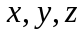):

(a) (4,6, 2) (b) (2,3,11) (c) (0, 2, 16) (d) (4,5,4) (e) NOTA

5. Let A be a 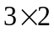 matrix and let B be a 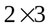 matrix. How many of the following products are
defined?

I.
II.
III.
IV.

A. 1 B. 2 C. 3 D. 4 E. NOTA

6. What is the magnitude of the following vector:

A. 96 B. 98 C. 7 D. 49 E. NOTA

7. Calculate the cross product, of u = < 3, 1, 5> and v = < 2,5,1>.

A. B. C.
D. E. NOTA

8. Consider the following matrix: A = 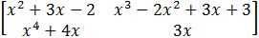

What is the sum of the coefficients of the polynomial that results from |A|?

A. -26 B. -19 C. -14 D. -13 E. NOTA

9. A matrix A is orthogonal if . Which of the following must be true of A?
- All columns are unit vectors
- All rows contain vectors that are perpendicular to each other

A. I only B. II only C. I,II D. None E. NOTA

10. What is the trace of the matrix, 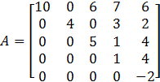

A. 18 B. 22 C. 400 D. 400 E. NOTA

11. How many of the following matrices are skew-symmetric, a matrix that has the property A = -A^{T} ?

A. 0 B. 2 C. 3 D. 4 E. NOTA

12. Consider two non-parallel vectors of length 6 and 10 respectively. The components of the two vectors are chosen in such a way that the magnitude of the cross products is maximized. What must be the value of the dot product of the two vectors?

A. 0 B. 30 C. 60 D. Not Enough Information E. NOTA

13. Which of the following vectors is perpendicular to the plane: 3x – 5y + 2z = 12?

A. B. C. D.
E. NOTA
14. Which of the following are true?

- |AB| =|A||B|
- (AB)⁻¹ = A⁻¹B⁻¹

A) I only B) II only C) I, II D) None E) NOTA

15. A set of n linearly independent vectors are put into a matrix, where n is the number of components of the vector. Which of the following CANNOT be true of this matrix?

- |M| = 0
- M is full rank
- It is possible for M to not be square.

- I B) I, II C) I, III D) II, III E) NOTA

16. Let a = < 1, 7, 9 >, b = < 3, 6, 4 >, and c = < 2, 5, 1>. Calculate the triple scalar product:

A) 5 B) 12 C) 24 D) 48 E) NOTA

17. What is the determinant of the following matrix?

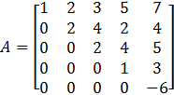

- 326 B) 4 C) -24 D) 429 E) NOTA

18. Find the sum of the elements of the inverse of the matrix A = 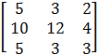

- B) C) D) 1 E) NOTA

19. Find a unit vector in the direction of

- 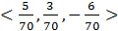 B)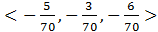 C)

D) E) NOTA

20. A real “positive definite” matrix, A, with dimensions n by n has the following property

This must be true for all real non-zero n-dimensional vectors x. A must also be symmetric. Which of the following are positive definite?

- 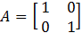

- 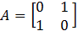

A) All of them B) I C) II D) None E) NOTA

21. Matrices and vectors are fundamental tools of Linear Algebra which is essentially the study of linear
transformations. A linear transformation, f, is a transformation or function with the following
properties:

Where x and y are in elements in the domain of f and a is a real number. Which of the following are linear transformations?

- For all real numbers x,
- For all complex numbers x,
- For all complex numbers x,

- All B) I, II C) I, III D) III E) NOTA

22. Let be a polynomial of a matrix A.. Define p and A, such that

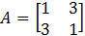

What are the sum of the entries of ?

- 10 B)15 C) 40 D) 60 E) NOTA

23. Consider the following matrix equation:

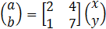

Now make the following substitution and . This leads to the following equation:

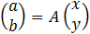
What is A?

- 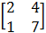 B) 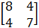 C) 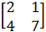 D) 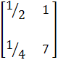 E) NOTA

24. Find the determinant of:

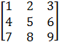

- 0 B) 12 C) 153 D) 6 E) NOTA

25. An eigenvalue, is a root to the polynomial formed after computing the following matrix operation:

Where I is the identity matrix. Given that:

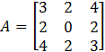

How many unique negative eigenvalues does A have?

- 0 B) 1 C) 2 D) 3 E) NOTA

26. Which of the following are nilpotent matrices (a nilpotent matrix has the property that for some value of k, and 0 is the zero matrix of appropriate dimension).

- 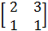 B) 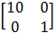 C) 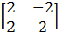 D) 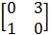 E) NOTA

27. What is the sum of the real roots of the equation: 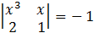 ?

- B) C) 1 D) 1.75 E) NOTA

28. Given that u = <4,9>. The sum of the components of the vector that is produced after rotating u about the origin 30º clockwise can be written in the form . What is a + b + c?

- 5 B) C) 9 D) 12 E) NOTA

29. The scalar projection of v = <5,12> onto u = <7,24> can be written in the form of where the fraction has been completely reduced. Determine a + b.

- B) C) 336 D) 3 E) NOTA

30. What is the volume of the tetrahedron with vertices (0,0,0), (1,1,1), (4,5,1), (5,9,2)?

- B) C) 6 D) 9 E) NOTA

