2012 Cyborg (Interschool) Test
- Some number “” has been placed on a picture of Boston. To get the picture, go to http://imageshack.us/f/27/hiddencodeforboston.jpg/. After finding this number, use John Conway’s Game of Life (search for this on google) and create a row of width one and length. Click the “next” button times and then count the number of populated cells remaining and let this number be “y”. Now, let “z” equal the number of the IBM computer that the first ever Game of Life program was written on (for example, if it was written on the IBM 1, then z would equal 1). The answer to this problem is + y + z.

- Go to http://armorgames.com/play/12745/this-is-the-only-level-3. Play the game until you reach the “PI IN THE SKY” level. How many digits are needed to continue to the next level?

- For this question, you will be given clues that will give you certain email addresses to send a message to. To find your first email address, find the base 2 equivalent of . Let this number be “x”. Then, send an email to the email address that begins with the letter “B” followed by “x” and then followed by “@yahoo.com”. (For example, if the number was “1000” [in base 2; do not put a two after the number in the email address], send an email to B1000@yahoo.com) An auto responder will immediately return a message to give you your next clue for your next email address. Also, you must use a gmail or yahoo account to send your emails so that your emails will not be sent to spam.

- For this question, use the list of real-life buildings in Boston listed below. From that list, you will need to find: (i) The sum the heights (in feet) of the 10 buildings that were built earliest and (ii) The sum of the heights (in feet) of the 10 tallest buildings. There may or may not be buildings that are on both lists. Once you get these 2 parts, then sum (i) and (ii).
Buildings: One Federal St., Prudential Tower, Harbor Towers One, Massachusetts General Hospital, Federal Reserve Building, One International Place, Westin Copley Place, State Street Trust Building, 33 Arch St., The Custom House, 28 State St., 75 State St., 111 Huntington Ave., One Beacon St., 101 Federal St., Keystone Building, The Boston Company Building, The New England Telephone Building, One Devonshire Place, One Post Office Sq., 125 High St., The First National Bank of Boston, The Exchange Place, McCormack Place, One Lincoln St., 100 Summer St.

- What is the name of the store in Boston that has an old, run-down storefront for its façade, but upon entering the store and going behind a secret entrance you will find an upscale clothing store?

- KenKen puzzle: If you don’t know how to play this game, look it up online.
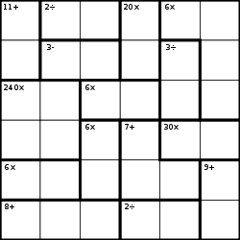

- The final answer to this problem is the sum of the answers of all of the following parts (part a through part dd).
  - Find the maximum number of points given for AP Art History in 2006 on Question 7.
  - How many total points is part A worth on Question 3 on the 2003 Form B AP Biology exam?
  - What is the value of k in part A on Question 6 on the 1999 AP Calculus AB exam?
  - What is the answer to part A on Question 1 of the 2004 Calculus BC exam?
  - How many total points is question 2 worth on the 2010 AP Chemistry exam?
  - What is the maximum number of total points that you can get on the story narration part of the AP Chinese Language exam in 2007?
  - How many free response questions are there on the 2008 AP Computer Science A exam?
  - How many questions are on the free response of the 2006 Form B AP English Language exam?
  - What is the maximum number of total points that you can get on question 1 of the 2010 AP English Literature exam?
  - How many total questions are on the free response of the 2004 AP Environmental Science exam?
  - How many total questions are on the free response of the 2007 AP European History exam?
  - What is the maximum number of total points that you can get on part B on questions 1-5 of the 2010 AP French Language exam? (Sum up the points of each part B for every question)
  - On the picture sequence, what is the maximum number of points on the 2004 AP German Language exam?
  - What is the total number of free response questions on the 2001 AP Human Geography exam?
  - How many total multiple-choice questions are there on the 2011 AP Italian Language exam?
  - What is the total number of points that you could get on the “Conversation” portion of the 2010 AP Japanese Language exam?
  - How many total free responses are there on the 2008 AP Latin Vergil exam?
  - What is the total writing time (do not include planning time) allowed on free response section of the 2005 AP Macroeconomics exam?
  - On question 3 of the 2001 AP Microeconomics exam, what is the number of cars washed per day when the number of workers is equal to two?
  - On the 2009 AP Music Theory exam, what is the “suggested time” (this suggested time being the suggested time given on the AP exam itself… give answer in minutes) for question 5?
  - For the 2007 Form B AP Physics B exam, what is the value of on part B of question 6?
  - How many total questions were there on the free response of the 2005 AP Physics C: Mechanics exam?
  - What is the total time given in minutes on the free response section of the 2010 AP Physics C: Electricity and Magnetism exam?
  - How many total free response questions are there on the 2006 AP Psychology exam?
  - How many total multiple choice questions are there on Part A of Section 1 of the AP Spanish Language Exam according to the exam format section from the 2009-2011 course description?
  - How many total free response questions are there on Section 2 of the AP Spanish Literature Exam according to the exam format section from the 2009-2011 course description?
  - What was the maximum number of points possible to obtain on question 4 on the 2009 AP Statistics exam?
  - On the 2010 AP Studio Art: Drawing exam, how many total sections were there?
  - How many total documents were there on Part A of the 2009 AP United States History exam?
  - What is the total number of multiple choice questions on the AP World History exam according to the course description effective as of the fall of 2010?

- The symbols below represent numbers in some number system. Find the value for the symbol(s) in each part, then sum the 4 parts to get the final answer.
  - 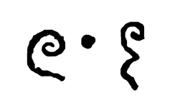

- The following code below is a computer program written in the Java programming language. The class “RandomMath” shown below is used in the class “tester” that is shown after “RandomMath”. What is the value of the int “answer” when the following code has been compiled?

public class RandomMath {
public static double method1(double[][] m){
for(int i = 0; i < m.length; i++){
if(m.length != m[i].length){
System.err.print("Cannot complete method.");
RuntimeException e = new RuntimeException();
throw(e);
}
}
if(m.length == 2){
return (m[0][0]*m[1][1] - m[1][0]*m[0][1]);
}
else{
double x = 0;
for(int i = 0; i < m.length; i++){
x += Math.pow(-1, i) * m[i][0] * method1(method2(m, i, 0));
}
return x;
}
}

public static double[][] method2(double[][] m, int a, int b){
double[][] x = new double[m.length-1][m[0].length-1];
for(int r = 0; r < x.length; r++){
for(int c = 0; c < x[0].length; c++){
if(r < a && c < b){
x[r][c] = m[r][c];
} else if(r >= a && c < b){
x[r][c] = m[r+1][c];
} else if(r < a && c >= b){
x[r][c] = m[r][c+1];
} else{
x[r][c] = m[r+1][c+1];
}
}
}
return x;
}

public static double method3(double[][] m){
double x = 0;
int r = 0;
int c = 0;
while(r < m.length && c < m[0].length){
x += m[r][c];
r++;
c++;
}
return x;
}

public static double[][] method4(double[][] m){
for(int i = 0; i < m.length; i++){
if(m.length != m[i].length){
System.err.print("Cannot compute");
RuntimeException e = new RuntimeException();
throw(e);
}
}
if(method1(m) == 0){
System.err.print("Cannot compute");
RuntimeException e = new RuntimeException();
throw(e);
}
double[][] x = method6(m);
for(int r = 0; r < m.length; r++){
for(int c = 0; c < m[0].length; c++){
x[r][c] /= method1(m);
}
}
return x;
}

public static double[][] method5(double[][] m){
double[][] x = new double[m[0].length][m.length];
for(int r = 0; r < m.length; r++){
for(int c = 0; c < m[0].length; c++){
x[c][r] = m[r][c];
}
}
return x;
}

public static double[][] method6(double[][] m){
double[][] x = new double[m.length][m[0].length];
for(int r = 0; r < m.length; r++){
for(int c = 0; c < m[0].length; c++){
x[r][c] = Math.pow(-1, r + c) * method1(method2(m, r, c));
}
}
x = method5(x);
return(x);
}

public static double[][] method7(double[][] m, double[][] n){
if(m[0].length != n.length){
System.err.print("Cannot compute.");
RuntimeException e = new RuntimeException();
throw(e);
}
double[][] x = new double [m.length][n[0].length];
for(int r = 0; r < x.length; r++){
for(int c = 0; c < x[0].length; c++){
for(int a = 0; a < m[0].length; a++){
x[r][c] += m[r][a] * n[a][c];
}
}
}
return x;
}
}

public class tester {
public static void main(String[]args){

double[][] x1 = new double [5][5];
for(int r = 0; r < x1.length; r++){
for(int c = 0; c < x1[0].length; c++){
if(r >= c)
x1[r][c] = (r + c);
}
}

int i1 = (int) RandomMath.method1(x1);

int i2 = (int) RandomMath.method3(x1);

double[][] x2 = { {2,3,2}, {10,12,5}, {5,5,1}};

double[][] x3 = RandomMath.method4(x2);

int i3 = (int) x3[1][2];

double[][] x4 = {{14,9,3}, {2,11,15}, {0,2,17}, {5,2,3}};
double[][] x5 = {{12,25}, {9,10}, {8,5}};

double[][] x6 = RandomMath.method7(x4, x5);

int i4 = (int) x6[2][1];

int answer = i1 + i2 + i3 + i4;
}
}

- State the city and country (or state if in the United States of America) of the following sculptures/ buildings.
  - 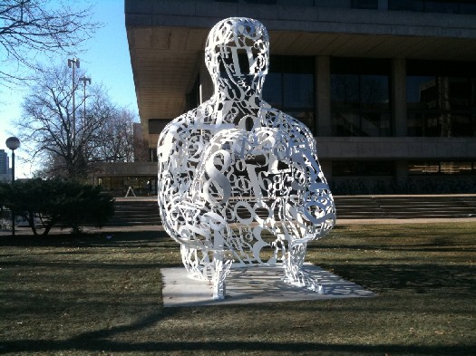
  - 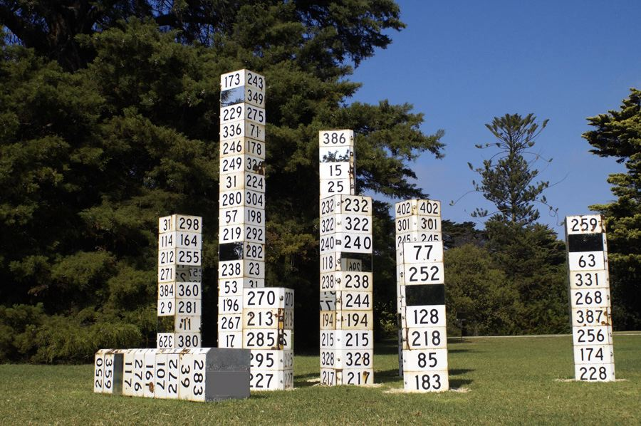
  - 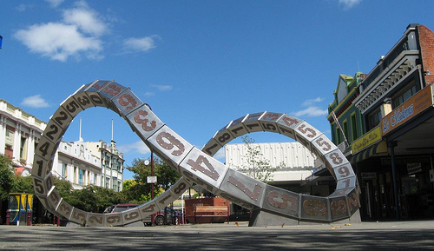
  - 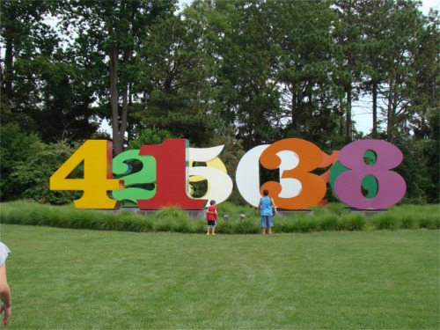
  - The following is a graphic design for a future building; name the planned location of the building: 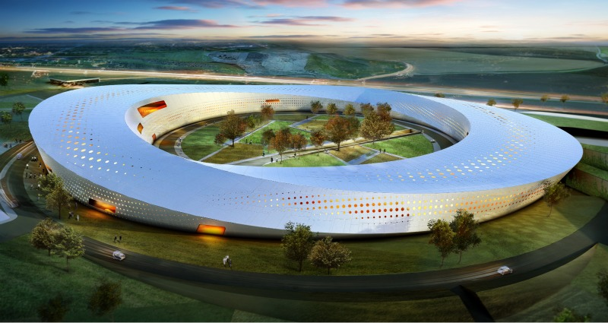
  - 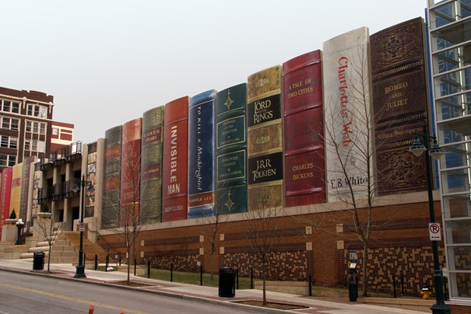
  - 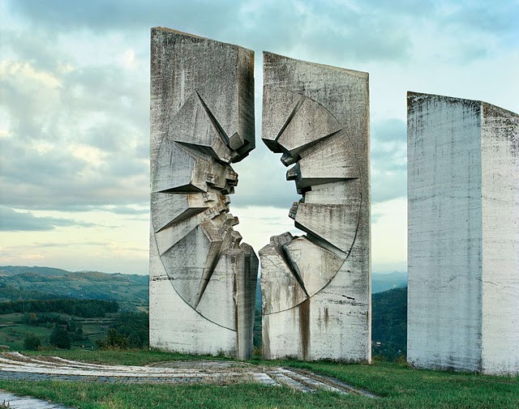
  - 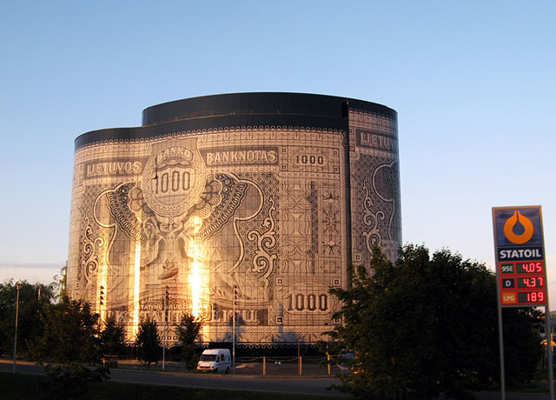
  - 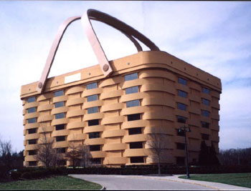
  - 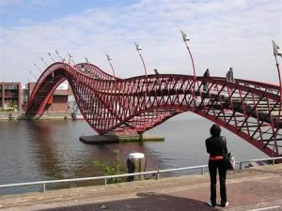

  - What is the birth year of the Atlanta Braves’ player (or ex-player) who named his child after an old enemy stadium?
  - First, find the name of the first United States born hockey player that played in the NHL. The answer to this question is the year that he won the Hart Memorial Trophy.
  - The player found in the previous question was also the last active player to play for a certain team. Find the number of regular season wins this team had in its final season.
  - Find the year in which the NFL Hall of Fame’s most expensive renovation was completed (do not include planned renovations in looking at the costs).
  - A certain athlete made sports history by becoming the first woman to play in one of the four major sports leagues in the United States (these leagues consist of the NFL, NHL, NBA, and MLB). Find the year that the team that this person played for won their first championship for their league (this does not mean the first time the team won while she was on team; just when the team won the first time in general).
  - Find the year that the first goaltender to wear a facemask in the NHL was inducted into the Hockey Hall of Fame.
  - First, find the two teams that played in the very first NHL game. Then, find out which of the two teams did not complete their games that season. The answer to this question is the year that that team’s last active player in the NHL ended his career.
  - Find the year that the first goalie in the NHL won the Stanley Cup while acting as the team captain.
  - First, find the first team in the NHL to pull their goaltender for an extra skater. Then, find the number of times this team has won the Stanley Cup.
  - What pitcher gave up more homeruns in the MLB to Hank Aaron than any other pitcher in history?
  - First, find the pitcher that Pete Rose had the most hits against. Then, the answer to this question is the number of earned runs that this pitcher gave up during his Major League career.
  - A certain major league player stole 50 consecutive bases in the MLB without being caught. First, find the team who stopped this streak. Then, find a second team that the first team played in the first team’s final game before being relocated to a new city. The answer to this question is the year that the second team won their second World Series championship.
  - First, find the player that in 1962 went 84 consecutive games without throwing a single base on balls in MLB. Then, find the team that he played for the year he accomplished this feat. The answer to this question is the number of wins this team obtained in 1962.
  - Hockey players are known for being very superstitious. First, find the name of the player in the NHL who refused to talk to anyone on game days after 1:30 P.M. In one of his NHL seasons, he was the only member of his team to play in every game of the season. The answer to this problem is the number of penalty minutes he received during this season.

  - A certain NHL team is known for not staying in a hotel if they lose continuously when staying in the hotel the night before. Find this team. Then, find the year that the team’s home arena last hosted the NHL All-Star game. Now, find the year that the team’s home city last hosted the NHL entry draft. The answer to this question is the sum of the two years you have found.

- a. The book, Flatlands, by Abbott, is divided into 2 parts. What are the names of these 2 parts?
b. How many chapters are in the book Innumeracy, by Paulos?
c. Who wrote the introduction to the book The Calculus Virgin, by Hayman?
d. In The Last Lecture, by Randy Pausch, what is the title of the 5th chapter?
e. What is the name of the main character in the book Stranger in a Strange Land by Heinlein?
f. In this book (first written in 1937) by a famous author, the main character chooses his name to be Prometheus and his partner’s name to be Gaea after fleeing from the city to the Uncharted Forest. What is the title of this book AND who is the author?
g. In the book Songmaster, by Orson Scott Card, what are the Songbirds?
h. The book The Hobbit, A Prelude to Lord of the Rings is also known by another name. What is that other name?
i. What year was the first printing of the book Behold the Man by Michael Moorcock?
j. In the book Message in a Bottle by Nicholas Sparks, a lady finds a bottle washed up on shore with a message inside it. What is the date on the message she found (month, day and year)?

- What one number do these 2 pictures represent?

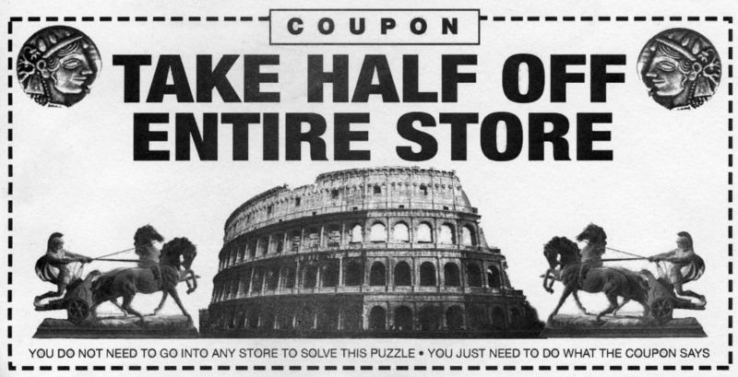

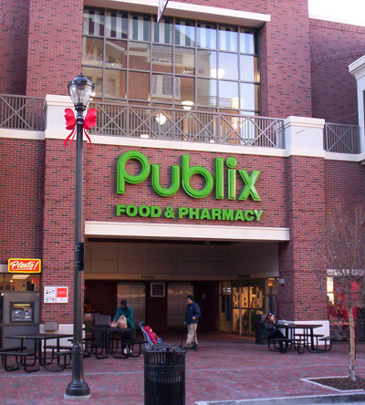

- What one number do these 3 pictures represent?

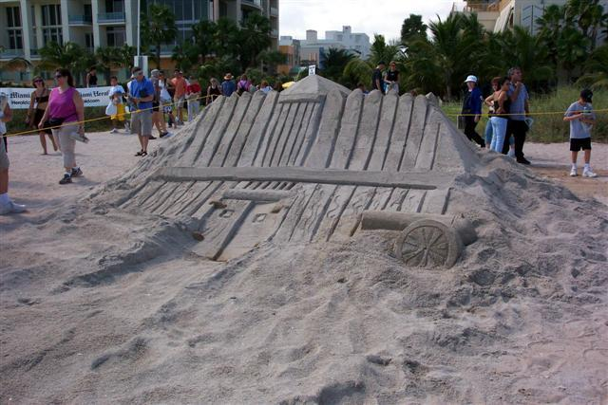

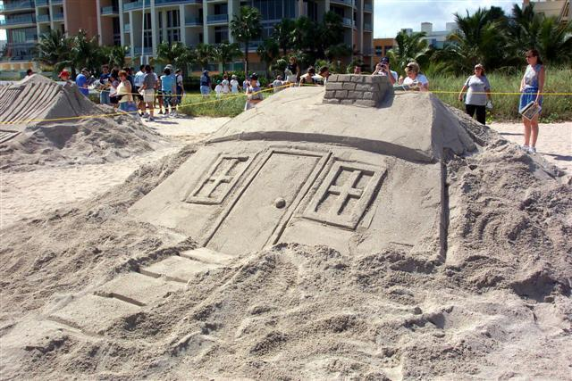

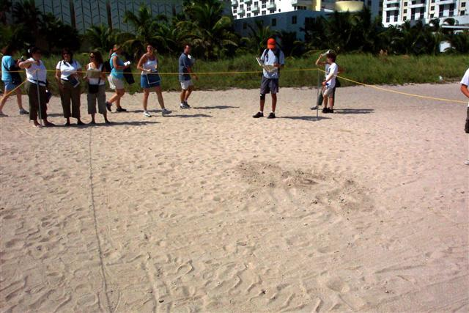

- What one number do these 4 candy wrappers represent?

