2012 Cyborg (Interschool) Answers

1. =16777216, y = 20, z = 360; final answer = 16777596
2. 9
3. 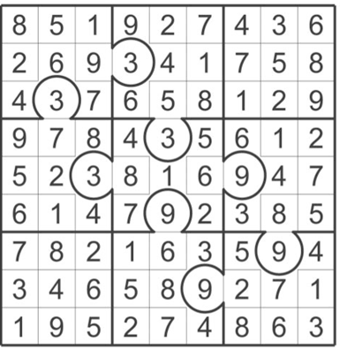
4. Ten Earliest Ten Tallest
The Custom House—1915—496ft Prudential Tower—750ft
State Street Trust Bldg—1930—245ft Federal Reserve Bldg—604ft
New England Telephone Building—1947—298ft Boston Company Bldg—601ft
Prudential Tower—1964—750ft One International Place—600ft
Boston Company Bldg—1969—601ft First National Bank of Boston—591ft
28 State St.—1969—500ft 111Huntington Ave—554ft
First National Bank of Boston—1971—591ft One Post Office Sq.—525ft
Keystone Bldg—1971—400ft One Federal St.—520ft
Harbor Towers One—1971—400ft The Exchange Place—510ft
One Beacon St.—1972—505ft One Beacon St.—505ft
Sum = 4786ft Sum = 5760ft

TOTAL = 10546ft

5. Bodega
6.
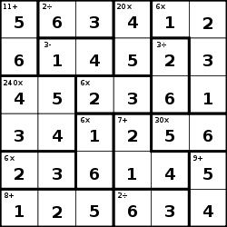

7. a) 4
b) 4
c) 9/2
d) 2474
e) 10
f) 6
g) 4
h) 3
i) 9
j) 4
k) 7
l) 25
m) 6
n) 3
o) 70
p) 6
q) 8
r) 50
s) 35
t) 15
u) 1.5
v) 3
w) 45
x) 2
y) 34
z) 3
aa) 4
bb) 3
cc) 10
dd) 70
Sum = 2923

8. a) 605
b) 0
c) 1572
d) 39
Sum = 2216

9. i1 = 0
i2 = 20
i3 = -10
i4 = 105
Answer = 115

10. a) Cambridge, Massachusetts
b) Melbourne, Australia
c) Palmerston, New Zealand
d) Indianapolis, Indiana
e) Lund, Sweden
f) Kansas City, Missouri
g) Kadinjaca, Yugoslavia
h) Kaunas, Lithuania
i) Newark, Ohio
j) Amsterdam, Netherlands

11. a) Chipper Jones, born in 1972, named his child Shea after the Mets’ Shea Stadium
b) Billy Burch, although having grown up in Canada, was technically the first American born player. He won the Hart Memorial in 1925
c) Billy Burch was the last active member to have played for the Hamilton Tigers. The final year for the team was the same year that Burch won the Hart Trophy. In the regular season, the team recorded 19 wins.
d) The NFL Hall of Fame’s biggest expansion was finished in 1995, costing about $9.2 million.
e) On Wednesday, September 23rd, 1992, Manon Rheaume played an exhibition game for the Tampa Bay Lightning. The team’s first Stanley Cup championship came in 2004.
f) Although Jacques Plant popularized the mask in 1959, Clint Benedict wore a facemask in 1930 for a few weeks. He was inducted in 1965.
g) The first NHL game took place between the Montreal Wanderers and Toronto Arenas. The Montreal Wanderers did not complete their season that year. The last active Wanderers player was George Geran, who played his last NHL game in 1926.
h) Charlie Gardiner, Chicago Black Hawks, 1933-34.
i) The Boston Bruins were the first team to pull their goalie. The goalie was Tiny Thompson and he played for Detroit and Boston both. They have won the cup for a total of 17 times in their existence.
j) Don Drysdale gave up 17 homeruns to Hank Aaron.
k) Phil Niekro gave up 64 hits to Pete Rose. He ended up allowing 2012 earned runs during his career.
l) Vince Coleman’s stole base streak was stopped by the Montreal Expos in 1989. The Montreal Expos played their final game against the New York Mets in 2004. The Mets last won the World Series in 1986.
m) Bill Fischer did so for the Kansas City Athletics in 1962. They won 72 games in 1962.
n) Stéphane Quintal is known for this superstition. In 1998-1999, he was the only member of the Montreal Canadiens to have played in every game. He earned 84 PIMs.
o) The Ottawa Senators are known for this superstition. They hosted the All-Star game in 2012. They hosted the NHL entry draft in 2008. The sum is 4020.

12. a. Part 1—This World
Part 2—Other Worlds
b. Five
c. Leithold
d. “It’s About How You Live Your Life”
e. Valentine Michael Smith
f. Anthem by Ayn Rand
g. People who had amazing voices that were given to others that deserved them.
h. There and Back Again
i. 1966
j. July 22, 1997

13. 59 (LIX in Roman Numerals)
14. 4000 (Fort House Sand)
15. 4012 (3 + 3 (Ruth’s #) + 2000 =
2006—then doubled)

