1. Find a slope-intercept form equation for the line through $\left(3,5\right)$ and $\left(-4,7\right)$.
 $y={-7}/2x+{31}/2$

 $y={-2}/7x-{41}/7$

 $y={-2}/7x+{41}/7$

$y={-7}/2x+{41}/7$

1. None of the Above
2. The distance from a point  to the plane with equation  is 3. If  are all non-negative integers, find the value of .
   1. 1
   2. 2
   3. 3
   4. 4
   5. None of the Above
3. Find the number of quadruples  of positive even integers such that .
   1. 560
   2. 450
   3. 340
   4. 220
   5. None of the Above
4. Find the area of the region of the  defined by the inequality .
   1. 
   2. 4
   3. 
   4. 8
   5. None of the Above
5. 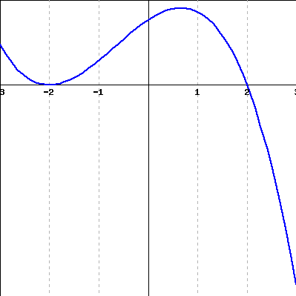Which of the following is a possible equation representing this graph?
 $y=-{\left(x+2\right)}^{2}(x-2)$

 $y={\left(x+2\right)}^{2}(x-2)$

 $y=-{\left(x-2\right)}^{2}(x+2)$

$y={\left(x+2\right)}^{2}(2-x)$

1. None of the Above
6. Find the minimum value of the following equation:
 $$y=\frac{1}{4}x^{2}-3x+5$$

  1. -6
   2. -4
   3. 77
   4. 87
   5. None of the Above
7. Choose the best option below to describe the graph of

the equation:

* 1. Bounded Above
  2. Bounded Below
  3. Bounded
  4. Unbounded
  5. None of the Above

1. Which of the following equations has a graph with removable discontinuity?
 $f\left(x\right)= \left\{\begin{matrix}x^{2} x≠2 \\ 4 x=2\end{matrix}\right\}$

 $f\left(x\right)=\frac{x^{2}-5x-6}{x^{2}-9}$

 $f\left(x\right)=\frac{x^{3}-\frac{1}{2}x^{2}-4x+2}{x^{2}-\frac{9}{2}x+2}$

$f\left(x\right)=\frac{x}{x-1}$

1. None of the Above
2. Which of the following functions have graphs that intersect their horizontal asymptotes?
 $f\left(x\right)=\frac{x}{2x^{2}+5x}$

 $f\left(x\right)=\frac{x^{3}+1}{2x^{2}+5x-3}$

 $f\left(x\right)=\frac{x+1}{2x^{2}+5x-3}$

$f\left(x\right)=\frac{1}{2x^{2}+5x-3}$

1. None of the Above
3. Given a function $f$, which of the following represents a vertical stretch by a factor of 2?
 $y=f(2x)$

 $y=f(\frac{x}{2})$

 $y=2f(x)$

$y=f\left(x\right)+2$

1. None of the Above
4. Let $f\left(x\right)=-2x^{\frac{-1}{2}}$, which of the following is true?
 $f\left(0\right)=0$

 $f\left(1\right)=1$

 $f(2)=1$

$f\left(-1\right)=2$

1. None of the Above
5. $Given: \frac{-9}{x^{2}-9}=\frac{A}{x+3}-\frac{B}{x-3}$. Find A+B.
   1. 0
   2. 2
   3. 3
   4. 6
   5. None of the Above
6. Find a polynomial function with leading coefficient 2, degree 4, with -3, -1, 0, and $\frac{5}{2}$ as zeroes.
 $y=2x^{4}+3x^{3}-14x^{2}+15x$

 $y=2x^{4}+3x^{3}+14x^{2}-15x$

 $y=2x^{4}-3x^{3}-14x^{2}-15x$

$y=2x^{4}+3x^{3}-14x^{2}-15x$

1. None of the Above
7. Find the asymptotes and intercepts of the following equation: $h\left(x\right)=\frac{2x^{3}-3x+5}{x^{2}-4}$.
 $x=-2,x=2, y=0$

 $x=-2,x=2$

 $x=-2,x=2, y=2$

$x=-2,x=2, y=2x$

1. None of the Above
8. The amount *C* in grams of carbon-14 present in a certain substance after *t* years is given by $C=14e^{- \frac{t}{8}}$. How many years will it take for the amount of carbon-14 present to reduce by 50%?
 $\ln\left(512\right)$

 $\ln\left(256\right)$

 $\ln\left(64\right)$

$\ln\left(2\right)$

1. None of the Above
9. Which of the following is the inverse of $f\left(x\right)=20∙{14}^{x}$?
 $f^{-1}\left(x\right)=\log_{14}\left(\frac{x}{20}\right)$

 $f^{-1}\left(x\right)=\log_{20}\left(\frac{x}{14}\right)$

 $f^{-1}\left(x\right)=20\log_{14}\left(x\right)$

$f^{-1}\left(x\right)={14log}_{20}\left(x\right)$

1. None of the Above
10. Solve: $2\log\left(x+1\right)-3log6<0$
 $x<6\sqrt{6}-1$

 $x<6\sqrt{6}$

 $-1<x<5$

 $-1<x<6\sqrt{6}$

1. None of the Above
11. The graph of $y=csc⁡(x)$ intersects the graph of:
 $y=x$

 $y=x^{2}$

 $y=sec⁡(x)$

 $y=cos⁡(x)$

1. None of the Above
12. Solve: $\sin^{-1}\left(cos\left(\sin^{-1}\left(-1\right)\right)\right)=x$
    1. 0
 $\frac{π}{2}$

 $π$

 $\frac{3π}{2}$

 2. None of the Above
13. Find the sum of the period and vertical shift of the following trigonometric equation:
 $$y=-2\tan\left(3πx-6π\right)+1$$

 $4/3$

 $5/3$

 ${11π}/3$

${13π}/3$

1. None of the Above
14. Find all solutions on the interval $\left[-2π,2π\right]$ for the equation: $2\sin^{2}x+3sinx=2$.
 $x={5π}/6, {7π}/6 ,- {5π}/6, {-7π}/6$

 $x=π/6, {11π}/6$

 $x={-π}/6, {-11π}/6 , {5π}/6, { 11π}/6$

 $x=π/6, {5π}/6 ,- π/6, {-7π}/6$

1. None of the Above
15. If $B=sin\frac{π}{4}cos\frac{π}{3}-cos\frac{π}{4}sin\frac{π}{3}$ and , find

.

* 1. None of the Above

1. Find the largest negative value for x that solves the equation: $\sin\left(2x\right)+\cos\left(2x\right)=0$.
 $\frac{-π}{16}$

 $\frac{-π}{8}$

 $\frac{-π}{4}$

$\frac{-π}{3}$

1. None of the Above
2. Identify the graph of the parametric curve: $x=2cos⁡(t) y=3sin⁡(t)$.
   1. Lemniscate
   2. Limacon
   3. Ellipse
   4. Hyperbola
   5. None of the Above
3. 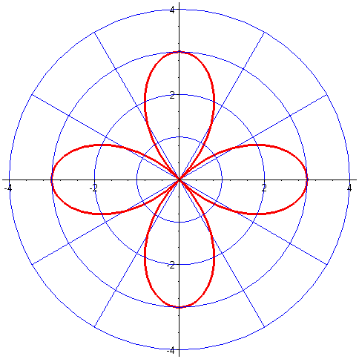Identify the equation of the polar graph shown below:
 $r=3cos⁡(2θ)$

 $r=2cos⁡(3θ)$

 $r=3cos⁡(4θ)$

$r=2cos⁡(2θ)$

1. None of the Above
4. Solve for z: $z^{3}=-8$. Which of the following is a possible value for z?
   1. 2
 $1+i\sqrt{3}$

 $-1+i\sqrt{3}$

 $-1+2i\sqrt{3}$

2. None of the Above
5. Solve for the sum of the entries in *X* if

$3X+A=B$, and and

* 1. 0
  2. 1
  3. 2
  4. 3
  5. None of the Above

1. Find the equilibrium point for the given supply and demand curve and then find the sum of the coordinate pair. $p_{demand}=200-15x$ $p_{demand}=50+25x$
   1. 137.5
   2. 140.5
   3. 144.5
   4. 147.5
   5. None of the Above
2. Solve for : 
   1. 
   2. 
   3. 3
   4. 4
   5. None of the Above
3. Find the real solution to the equation .
   1. 
   2. 
   3. 
   4. 
   5. None of the Above