For all questions, answer E. "NOTA" means none of the above answers is correct. The logarithmic function is well defined for complex arguments. Further, the principal value of a logarithm is such that its imaginary part lies on 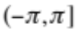. (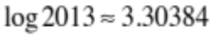)

1. A farmer wants to build a fence along a river such that the side parallel to the river costs $6/foot and the sides perpendicular to the river cost $5/foot. Given that the farmer has $1500.00 to spend, what is the maximum area, in square feet, the given fence can contain?

A)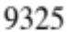 B) 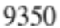 C) 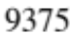 D)  E) NOTA

2. Evaluate 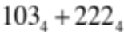 in binary.

A) 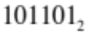 B) 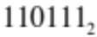 C) 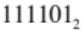 D) 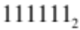 E) NOTA

3. Given a standard deck of cards find the probability that I am dealt two cards of the same rank (In a suit there are 13 different ranks).

A) 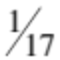 B) 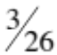 C) 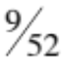 D) 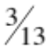 E) NOTA

4. In Combinatorics, the study of counting, there are multiple ways to look at a problem. Often identities can have both algebraic and “counting” arguments. For example, I could ask you to count the ways of choosing men from a group of 20 and 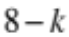 women from a group of 14. As I varied and summed over I would get an identity such that 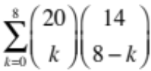 is equal to which of the following:

A) 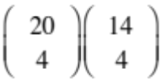 B) 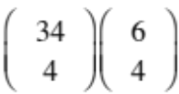 C) 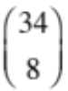 D) 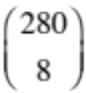 E) NOTA

5. Find 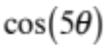 as a function of 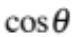 and 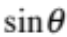.

A) B)
C) D)
E) NOTA

6. Simplify .
A)  B) 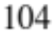 C) 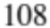 D) 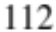 E) NOTA

7. Suppose there are three positive integers, such that the product of any two is a unique element of 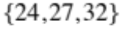. What is the product of all three integers?

A) 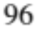 B)  C) 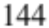 D) 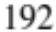 E) NOTA

8. Find the surface area of the solid formed by rotating the line 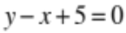 from 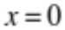 to 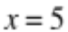 about the 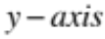.

A) 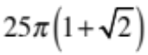 B) 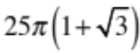 C) 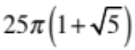
D) 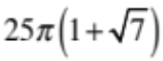 E) NOTA

9. Jim writes an MAΘ test in 32 hours. Together, Jim and Mike write the same test in 24 hours. How long would it take Mike, in hours, to write the test himself?

A) 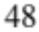 B) 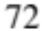 C) D) 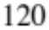 E) NOTA

10. Find 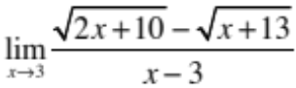 if it exists.

A)  B)  C) D) DNE E) NOTA

11. How many containers at 8% acid concentration need to be added to 24 containers at 12% acid concentration to reach a final solution with acid concentration 10%?

A)  B) 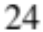 C) 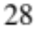 D) 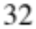 E) NOTA

12. Let 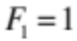, 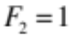 and 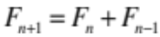. Given that the limit exists, evaluate 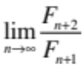.

A) 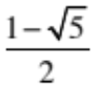 B) 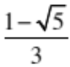 C) 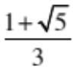 D) 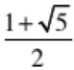 E) NOTA

13. What is the amplitude of 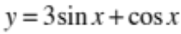?

A) B) 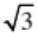 C) 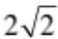 D) 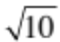 E) NOTA

14. How many words can be formed by the letters 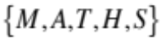? (Note, words can be of
any non-negative length, letters can only be used once, and letter order matters)

A) 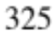 B) 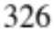 C) 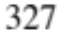 D) 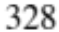 E) NOTA

15. Find the area of the triangle formed by the vectors 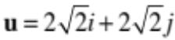 and 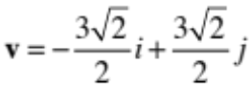.

A) B) C) D) E) NOTA
16. Solve for if 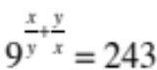 and 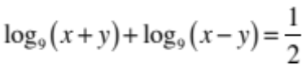.

A) B) C) D) E) NOTA

17. Evaluate 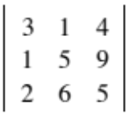

A)  B) 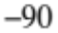 C) 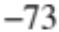 D) 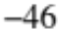 E) NOTA

18. For which value(s) 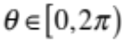 will 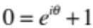

A) 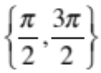 B) 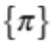 C) 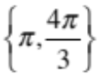 D) 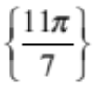 E) NOTA

19. Suppose the hour and minute hands of a clock are exactly together at noon. What is the exact time, in the format HH:MM:SS, at which the hands will first meet again?

A) 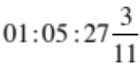 B) 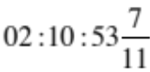 C) 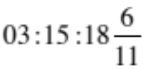

D) 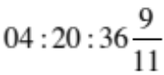 E) NOTA

20. What is the inverse of the conditional statement 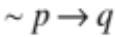?

A) 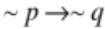 B) 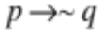 C) 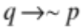 D) 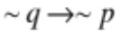 E) NOTA

21. Find the length of the third side of the triangle formed by the vectors 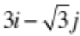 and 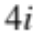.

A) B) 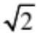 C) D) 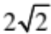 E) NOTA

22. I have $4.60 in quarters and dimes with 28 coins. How many quarters do I have?

A) 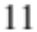 B) 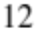 C) 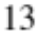 D) 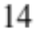 E) NOTA

23. An integer between 15 and 12303 (inclusive) is chosen at random. What is the probability that it is divisible by 2 or by 3?

A) 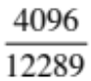 B) 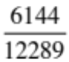 C) 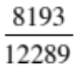 D) 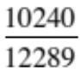 E) NOTA

24. Find all asymptotes of 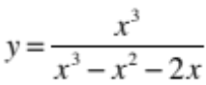.

A) 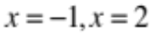 B) 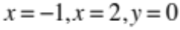 C) 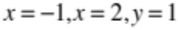
D) 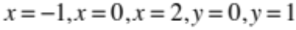 E) NOTA

25. Using Descartes’ Rule of Signs, what is the maximum possible number of negative roots of the polynomial ?

A) 1 B) 3 C) 5 D) 7 E) NOTA

26. A radioactive particle decays exponentially such that 3 grams remain twelve hours after its creation. Twenty-four hours after its creation, only 1 gram remains. What is the mass of the particle (in grams) after 48 hours?

A) B)  C) 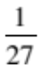 D) 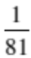 E) NOTA

27. Find the coefficient of 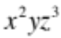 in the expansion of 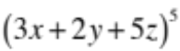.

A) 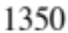 B)  C)  D) 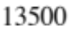 E) NOTA

28. Which of the following is a correct polar representation of 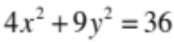?

A) 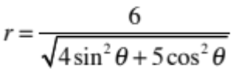 B) 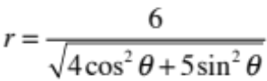 C) 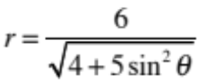
D) 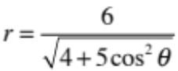 E) NOTA

29. What is the remainder when 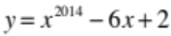 is divided by 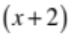?

A) 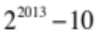 B) 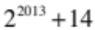 C) 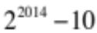
D) 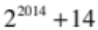 E) NOTA

30. Evaluate the infinite sum: 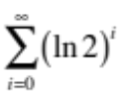.
A) B) 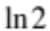 C) 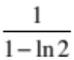 D) Divergent E) NOTA

