MU STATE BOWL- MAΘ National Convention 2014

**QUESTION NUMBER 1**

All of the horizontal asymptotes for the following functions can be expressed in the form y = α. Find the sum of all such values of α.



MU STATE BOWL- MAΘ National Convention 2014

**QUESTION NUMBER 1**

All of the horizontal asymptotes for the following functions can be expressed in the form y = α. Find the sum of all such values of α.



MU STATE BOWL- MAΘ National Convention 2014

**QUESTION NUMBER 2**



Give the value of A + 54B + C + D.

MU STATE BOWL- MAΘ National Convention 2014

**QUESTION NUMBER 2**



Give the value of A + 54B + C + D.

MU STATE BOWL- MAΘ National Convention 2014

**QUESTION NUMBER 3**

If , then let A equal the value of  evaluated at the point where *x* = 1 and .

Find  if . Simplify this until you get a rational function of *x* and *y*, and let the answer be B(*x, y*).

Give the sum of A + B(*x, y*).

MU STATE BOWL- MAΘ National Convention 2014

**QUESTION NUMBER 3**

If , then let A equal the value of  evaluated at the point where *x* = 1 and .

Find  if . Simplify this until you get a rational function of *x* and *y*, and let the answer be B(*x, y*).

Give the sum of A + B(*x, y*).

MU STATE BOWL- MAΘ National Convention 2014

**QUESTION NUMBER 4**

A water trough is 1000 cm long and a cross-section has the shape of an isosceles trapezoid that

is 30 cm wide at the bottom, 80 cm wide at the top, and has height 50 cm. If the trough is being

filled with water at the rate of 1000 , let A be the rate (in cm/min) the water level is rising the instant the water is 30 cm deep.

Triangle ABC has side  increasing at a rate of 1 in/min, side  increasing at 2 in/min,

and ACB increasing at a rate of 30 degrees per minute. At the instant AC = 3, BC = 5, and

m(ACB) = , let B equal the rate at which the area of triangle ABC is changing (in ).

Give your answer as the ordered pair (A, B), ignoring units.

MU STATE BOWL- MAΘ National Convention 2014

**QUESTION NUMBER 4**

A water trough is 1000 cm long and a cross-section has the shape of an isosceles trapezoid that

is 30 cm wide at the bottom, 80 cm wide at the top, and has height 50 cm. If the trough is being

filled with water at the rate of 1000 cm3/min, let A be the rate (in cm/min) the water level is rising the instant the water is 30 cm deep.

Triangle ABC has side  increasing at a rate of 1 in/min, side  increasing at 2 in/min,

and ACB increasing at a rate of 30 degrees per minute. At the instant AC = 3, BC = 5, and

m(ACB) = , let B equal the rate at which the area of triangle ABC is changing (in ).

Give your answer as the ordered pair (A, B), ignoring units.

MU STATE BOWL- MAΘ National Convention 2014

**QUESTION NUMBER 5**



Give the value of .

MU STATE BOWL- MAΘ National Convention 2014

**QUESTION NUMBER 5**



Give the value of .

MU STATE BOWL- MAΘ National Convention 2014

**QUESTION NUMBER 6**

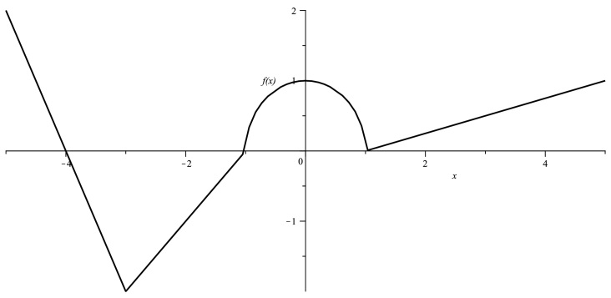

Above is the graph labeled as “f(x)” that consists of three line segments and a semicircle. Let . Put in ascending order*: g(−4), g(−1), g(5), g’(−2), g”(−2)*.

MU STATE BOWL- MAΘ National Convention 2014

**QUESTION NUMBER 6**

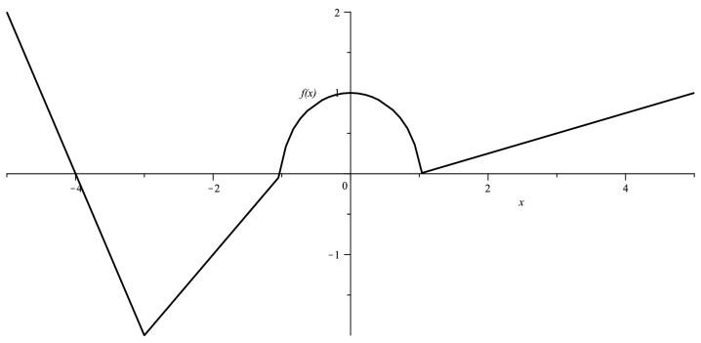

Above is the graph labeled as “f(x)” that consists of three line segments and a semicircle. Let . Put in ascending order*: g(−4), g(−1), g(5), g’(−2), g”(−2)*.

MU STATE BOWL- MAΘ National Convention 2014

**QUESTION NUMBER 7**

The velocity of a given particle is , where t ≥ 0 is measured in seconds. Let

*A* = the displacement (in units) in the first 8 seconds of movement,

*B* = the total distance traveled (in units) in the first 6 seconds of movement,

*C* = the average velocity (in units/second) in the first 8 seconds of movement,

*D* = the velocity of the particle (in units/second) the instant its acceleration is zero.

Give the numerical value of *A + B + C + D*, ignoring units.

MU STATE BOWL- MAΘ National Convention 2014

**QUESTION NUMBER 7**

The velocity of a given particle is , where t ≥ 0 is measured in seconds. Let

*A* = the displacement (in units) in the first 8 seconds of movement,

*B* = the total distance traveled (in units) in the first 6 seconds of movement,

*C* = the average velocity (in units/second) in the first 8 seconds of movement,

*D* = the velocity of the particle (in units/second) the instant its acceleration is zero.

Give the numerical value of *A + B + C + D*, ignoring units.

MU STATE BOWL- MAΘ National Convention 2014

**QUESTION NUMBER 8**

A true statement has value 1, while a false statement has value −1.

* The function  is differentiable at x = 0.
* The function  is differentiable at x = 0.
* The function  has a point of inflection at (0, 0).
* The value of  does not exist.

Find the sum of the values of the four statements above.

MU STATE BOWL- MAΘ National Convention 2014

**QUESTION NUMBER 8**

A true statement has value 1, while a false statement has value −1.

* The function  is differentiable at x = 0.
* The function  is differentiable at x = 0.
* The function  has a point of inflection at (0, 0).
* The value of  does not exist.

Find the sum of the values of the four statements above.

MU STATE BOWL- MAΘ National Convention 2014

**QUESTION NUMBER 9**

* Let (A, B) be the point on the line y = 5x + 8 closest to the origin.
* Let  be the equation of the line through the point (4, 5) that cuts off the least area from the first quadrant.
* Let *E* be the length of the base of the rectangle of largest area with sides parallel to the x− and y−axes that has its base on the x−axis and two vertices on the parabola .
* For the rectangle that has the maximum area inscribed in the graph of , let F be the length of the side parallel to the x−axis.

Give the sum *13(A + B) + C + D + 27E + 3F*, ignoring units.

MU STATE BOWL- MAΘ National Convention 2014

**QUESTION NUMBER 9**

* Let (A, B) be the point on the line y = 5x + 8 closest to the origin.
* Let  be the equation of the line through the point (4, 5) that cuts off the least area from the first quadrant.
* Let *E* be the length of the base of the rectangle of largest area with sides parallel to the x− and y−axes that has its base on the x−axis and two vertices on the parabola .
* For the rectangle that has the maximum area inscribed in the graph of , let F be the length of the side parallel to the x−axis.

Give the sum *13(A + B) + C + D + 27E + 3F*, ignoring units.

MU STATE BOWL- MAΘ National Convention 2014

**QUESTION NUMBER 10**

The function  has a local maximum value of 3 at x= −2 and a local minimum

value of 0 at x= −1.

The function f(x) is differentiable on . If f(1) = 10 and f′(x) ≥ 5 for x ∈ [1, 4], let  be the

minimum value of f(4).

Give the value of a + b + c + d + .

MU STATE BOWL- MAΘ National Convention 2014

**QUESTION NUMBER 10**

The function  has a local maximum value of 3 at x= −2 and a local minimum

value of 0 at x= −1.

The function f(x) is differentiable on. If f(1) = 10 and f′(x) ≥ 5 for x ∈ [1, 4], let  be the

minimum value of f(4).

Give the value of a + b + c + d + .

MU STATE BOWL- MAΘ National Convention 2014

**QUESTION NUMBER 11**









Give the value of  *A + B + C + D.*

MU STATE BOWL- MAΘ National Convention 2014

**QUESTION NUMBER 11**









Give the value of  *A + B + C + D.*

MU STATE BOWL- MAΘ National Convention 2014

**QUESTION NUMBER 12**

Region R in the plane is bounded by the graph of 16 + 25 = 400.

Let *A* equal the volume of the solid with base R that has semicircular cross-sections perpendicular to the x-axis.

Let *B* equal the volume of the solid with base R that has square cross-sections perpendicular to the y-axis.

Region S in the plane is the region bounded by the graphs of y = , x = 2, and y = 1 (where x ≥ 1 and y ≥ 1).

Let C equal the volume of the solid when S is rotated around the x-axis.

Let D equal the volume of the solid when S is rotated around the line x = 10.

Give the value of , ignoring units.

MU STATE BOWL- MAΘ National Convention 2014

**QUESTION NUMBER 12**

Region R in the plane is bounded by the graph of 16 + 25 = 400.

Let *A* equal the volume of the solid with base R that has semicircular cross-sections perpendicular to the x-axis.

Let *B* equal the volume of the solid with base R that has square cross-sections perpendicular to the y-axis.

Region S in the plane is the region bounded by the graphs of y = , x = 2, and y = 1 (where x ≥ 1 and y ≥ 1).

Let C equal the volume of the solid when S is rotated around the x-axis.

Let D equal the volume of the solid when S is rotated around the line x = 10.

Give the value of , ignoring units.

MU STATE BOWL- MAΘ National Convention 2014

**QUESTION NUMBER 13**

Let A equal the area between the graphs of y = sin x and y = cos x for x ∈ .

Let B equal the area bounded by the graphs of y = 6 and y =  in the first quadrant.

Let C equal the area bounded by the graphs of y =  and y = .

Let D equal the area bounded by the graphs of y = 20 − |x| and y = |3x|.

Find AD + BC − .

MU STATE BOWL- MAΘ National Convention 2014

**QUESTION NUMBER 13**

Let A equal the area between the graphs of y = sin x and y = cos x for x ∈ .

Let B equal the area bounded by the graphs of y = 6 and y =  in the first quadrant.

Let C equal the area bounded by the graphs of y =  and y = .

Let D equal the area bounded by the graphs of y = 20 − |x| and y = |3x|.

Find AD + BC − .

MU STATE BOWL- MAΘ National Convention 2014

**QUESTION NUMBER 14**

Let the equation of the tangent line to  =  + 2 at x = 1 be y = Ax + B.

Let the equation of the tangent line to  = ln x at x = e be y = Cx + D.

Let the equation of the tangent line to  = sin x + cos x at x =  be y = Ex + F.

Let the equation of the tangent line to  at x = 0 be y = Gx + H.

Give the sum ABCFGH + DE.

MU STATE BOWL- MAΘ National Convention 2014

**QUESTION NUMBER 14**

Let the equation of the tangent line to  =  + 2 at x = 1 be y = Ax + B.

Let the equation of the tangent line to  = ln x at x = e be y = Cx + D.

Let the equation of the tangent line to  = sin x + cos x at x =  be y = Ex + F.

Let the equation of the tangent line to  at x = 0 be y = Gx + H.

Give the sum ABCFGH + DE.